**Practical task**

**1.** Using methods of the **window object** create **:**

1) a new window with a size of 300x300 pixels.

2) with a delay of 2 seconds, resize the window to 500x500 pixels

3) with a delay of 2 seconds, move the window to the point with coordinates (200, 200)

4) with a delay of 2 seconds, close the window.

2 . For a given HTML page :

<p id ='text'>I learn JavaScript events!</p>

<div>

<button. . . . . >Change style!</button>

</div>

write a changeCSS() function that will trigger when the button is clicked and change the style of the content of the < p > tag: font color - orange, font size 20 ps, font family "Comic Sans MS" .

3. A page with 3 buttons and 1 link is given. Write Javascript code and implement an HTML page with appropriate events on each element:

1) 1st button – when you click on it, the background color of the page changes to blue

2) 2nd button – when you double-click it, the background color of the page changes to pink

3) 3 - the button - when you press and hold the button, the background color of the page turns brown. When released - white.

4) When hovering over the link, the background color becomes yellow, when hovering – white.

Example – the cursor is on a link.



4. Implement a program that will delete the selected item from the drop-down list when the button is pressed. All items can be deleted in any order.

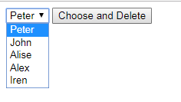

5. Implement a program that displays a message when a button is pressed

"I was pressed!", when hovering over the button will display the message "Mouse on me!", and when the mouse cursor is moved away will display the message "Mouse is not on me!".

Example of work :

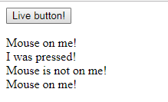

6. Implement a program that will monitor the change in size (width and height) of the browser window and display the corresponding values on the current page when it is stretched/shrunk.

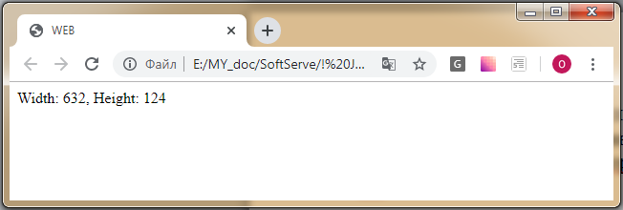

7 * . You need to implement 2 drop-down lists on the page. The first contains the names of countries, the second contains the names of cities. Implement work in such a way that when a certain country is selected from the left drop-down list, the cities of that country appear in the right drop-down list. The list of cities is formed dynamically , through JavaScript . You also need to display the name of the selected country and city below.

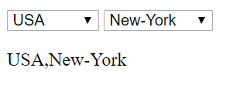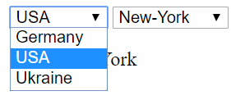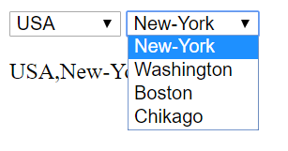

HTML page code :

<select name="country" id="country">

<option value="ger">Germany</option>

<option value="usa">USA</option>

<option value="ukr">Ukraine</option>

</select>

<select name="cities" id="cities"></select>

<p></p>